Quick Sort

In this and the next two sections, we discuss sorting algorithms that are usually of the order O(nlog2n). The first algorithm is quicksort. Quicksort described here is for array-based lists.

Quicksort uses the divide-and-conquer technique to sort a list. The list is partitioned into two sublists, and the two sublists are then sorted and combined into one list in such a way so that the combined list is sorted. Thus, the general algorithm is as follows:

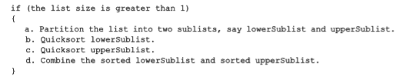  
  
After partitioning the list into two sublists—lowerSublist and upperSublist—these two sublists are sorted using quicksort. In other words, we use recursion to implement quicksort.  
  
  
To partition the list into two sublists, first we choose an element of the list called the pivot. The pivot is used to divide the list into two sublists: the lowerSublist and the upperSublist. The elements in the lowerSublist are smaller than the pivot, and the elements in the upperSublist are greater than the pivot. For example, consider the list in Figure 10-21.



There are several ways to determine the pivot. However, the pivot is chosen so that, it is hoped, the lowerSublist and upperSublist are of nearly equal size.

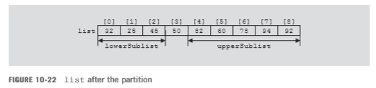

The partition algorithm is as follows: (We assume that pivot is chosen as the middle element of the list.)

1. Determine the pivot, and swap the pivot with the first element of the list. Suppose that the index smallIndex points to the last element smaller than the pivot. The index smallIndex is initialized to the first element of the list.
2. For the remaining elements in the list (starting at the second element) If the current element is smaller than the pivot
3. Increment smallIndex.
4. Swap the current element with the array element pointed to by smallIndex.
5. Swap the first element, that is, the pivot, with the array element pointed to by smallIndex.

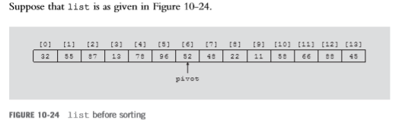

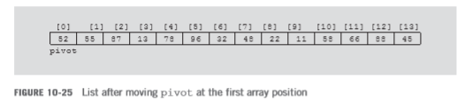

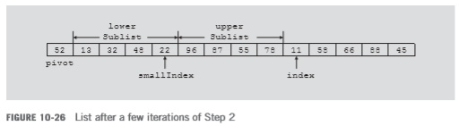

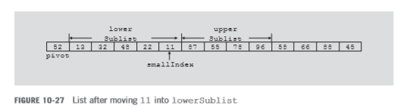

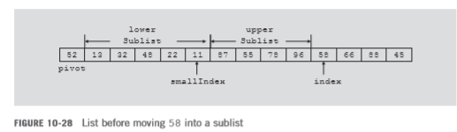  
  
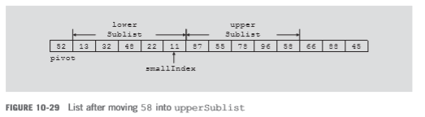  
  
  
  
  
  
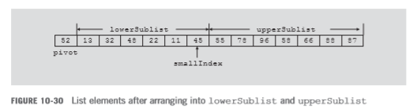

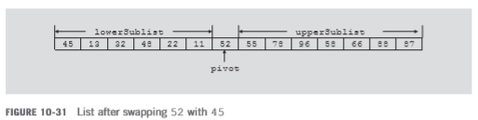

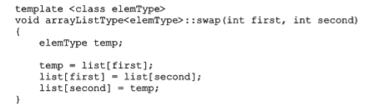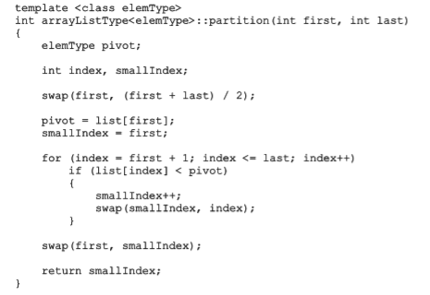Non-Recursive Version Quick Sort  
  
  
  
  
  
  
  
  
  
  
  
  
  
  
  
  
  
  
  
  
  
  
  
  
Recursive Version of Quick Sort

